**Problem Statement**

Create a react application on E Commerce website where you have the following functionalities.

**Login Page:**

This is the first page shown when we execute the react application.

1. Create a login page where we have **username** and **password** input fields and a submit button.
2. Once the input fields are filled, based on the user data available, we will render the home page of the application.
3. In case if the username or password is incorrect, show a message saying **incorrect username** or **incorrect password** accordingly.

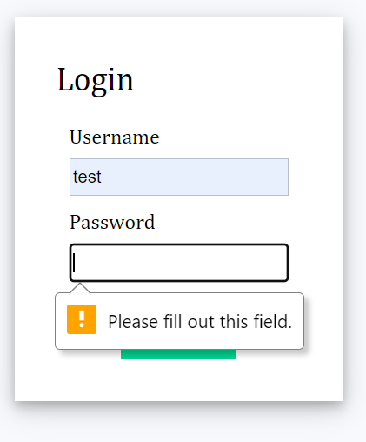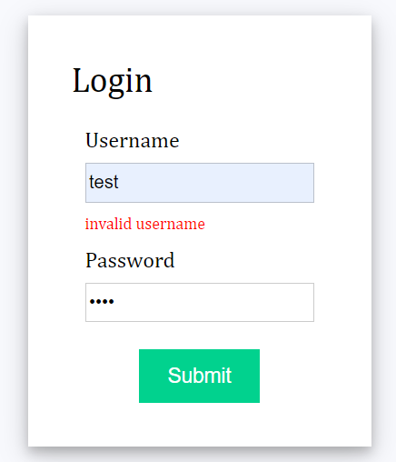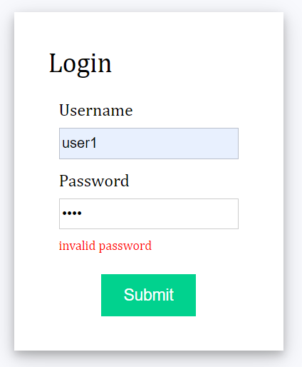

**Home Page:**

1. Design the homepage in 3 sections. Header, products and the cart section.
2. **The Header** section will show the Website name, Number of items in the cart and welcome message.



1. Products section will have the list of products, where images are fetched online.
   1. When hovered on the product, change the shadow.
   2. Each product contains, product image, name, price and Add to cart button.
   3. When clicked on the button, change the background color.
   4. Use the necessary css like flex grid, or anything of your choice.

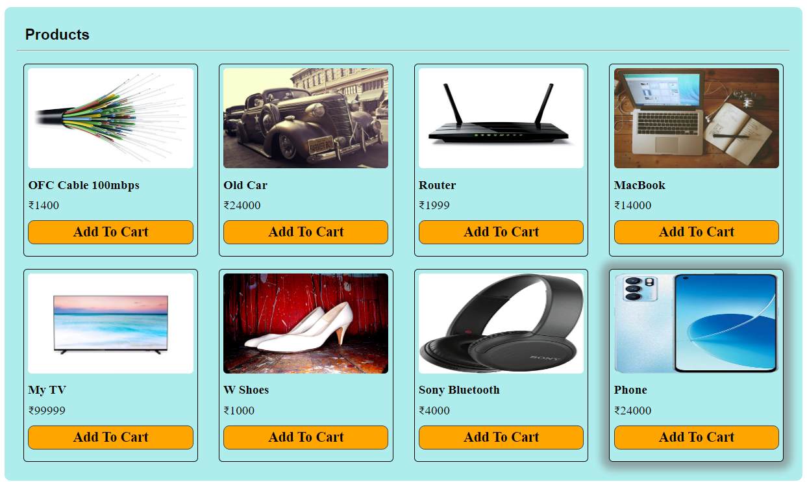

1. When clicked on the **Add to cart** button, add the item in the cart and show how many items are in the cart as shown below.



1. Show the cart page next to the products as shown below. The should operate in the following manner.
   1. When an item is added to the cart, the number of items in the cart should be shown in header.
   2. You should be able to increment or decrement the quantity of the product.
   3. When clicked on Plus(+) or minus, the quantity should be incremented.
   4. When the quantity of the product is 1, and clicked on Minus (-), the item should be removed from the cart if the quantity is more than 1, then decrement and update the price.
   5. According to the quantity the price and tax on the product should be updated.
   6. If multiple products are there in the cart, the total price should be calculated and displayed.
   7. Add a Checkout button and when clicked. When clicked on it, show an alert saying **“Implement checkout!”**

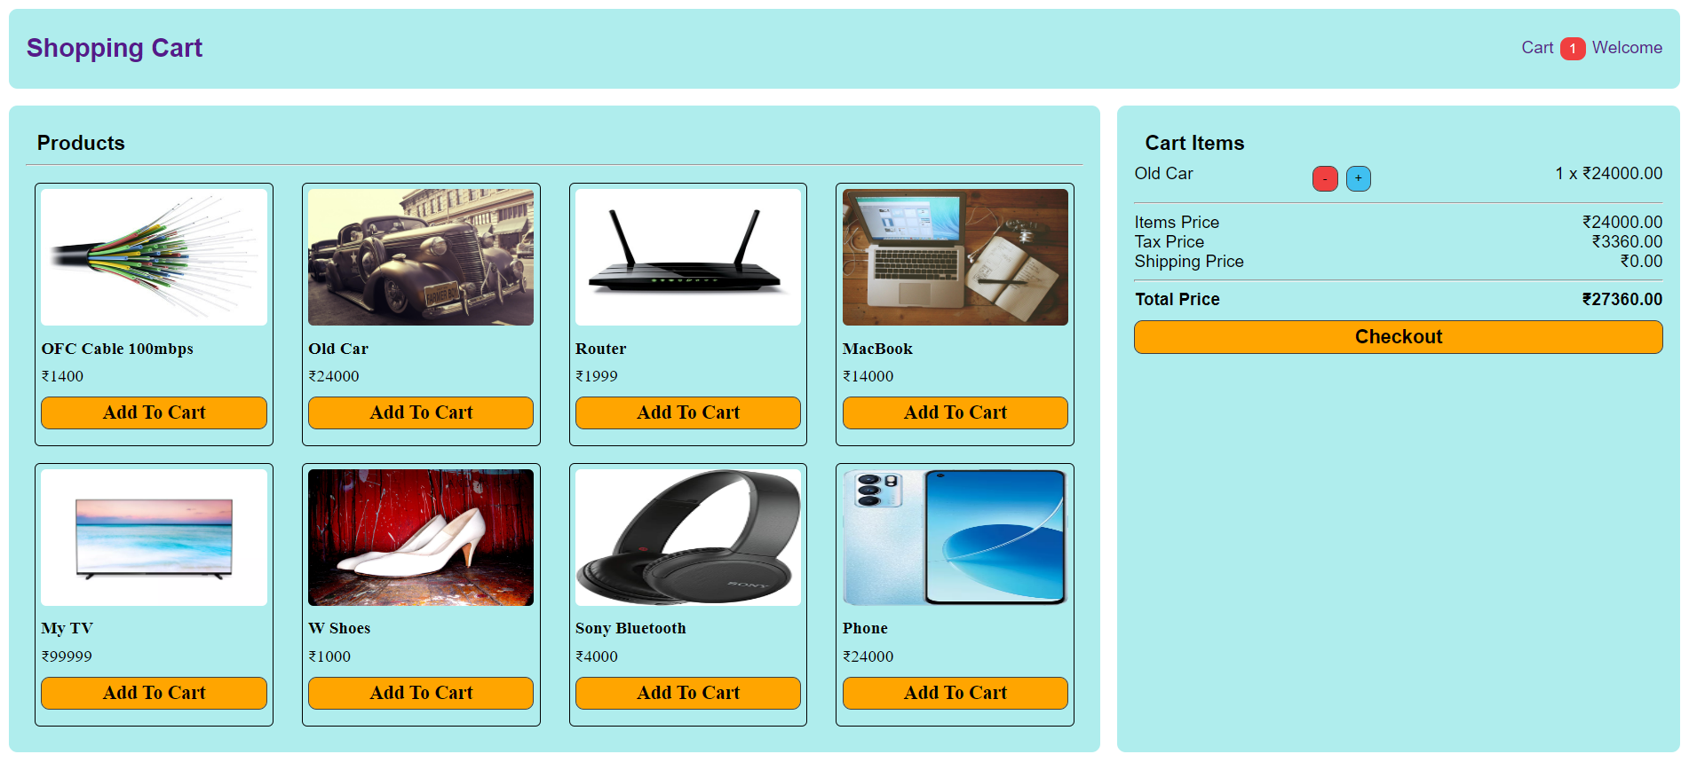

First the node version

Node –version

npm install create-react-app –g

create-react-app shopping-app

cd shopping-app

npm start

routing : it is use to navigate from one page to another page.

npm install react-router-dom

function App() {

let [msg,setMessage]=useState(“Welcome to react JS”)

return(

<div>

<Header info={msg} id=”100”></Heder>

<h2>Welcome to React JS Application {msg}</h2>

<Footer></Footer>

</div>

)

}

function Header(props) {

return(

<div>

<p>Header Component</p>

<p>{props.info} {props.id}</p>

</div>

)

}

function Footer() {

return(

<div>

<p>Footer Component</p>

</div>

)

}

<App></App>